EXPERIMENT-1
Roll number: 240701377 Name: Padma Priya D
USER INTERFACE AND DESIGN

COMAPARSION OF UI DESIGN BETWEEN TWO FIGMA CREATION

BAD DESIGN
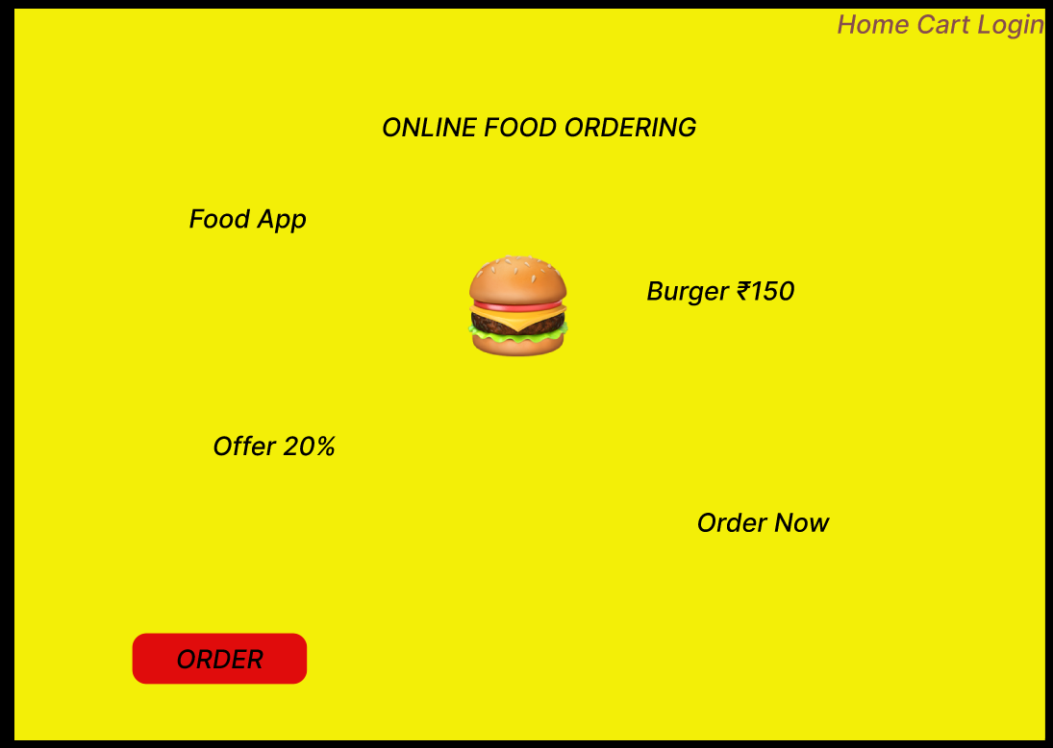
GOOD DESIGN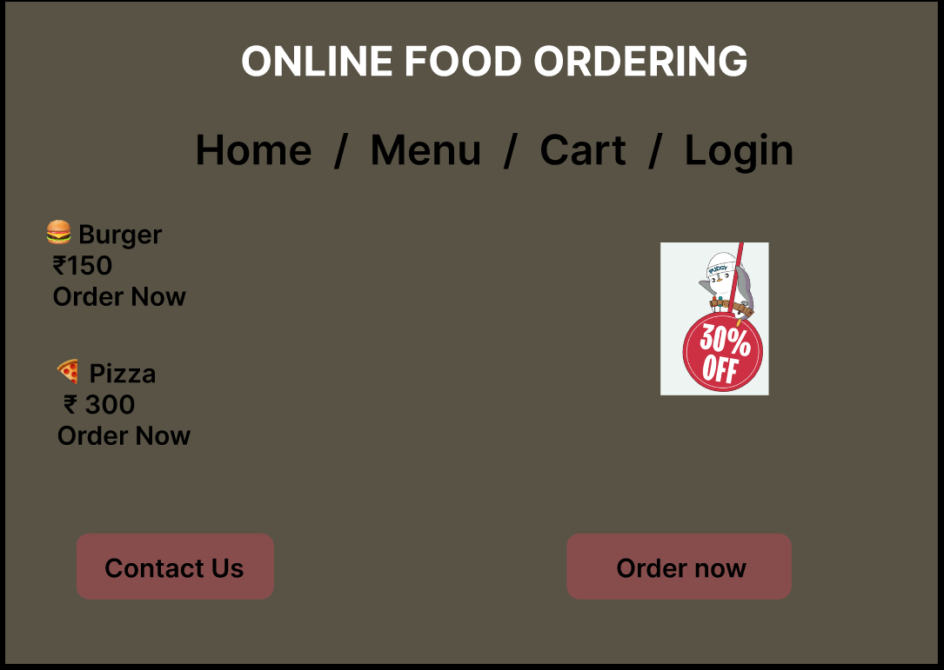
Prototype link:
https://www.figma.com/proto/9aipBi7aARXYpmybMdJGOM/UI-designs?node-id=1-2&t=l58GxiDHFqUuigHo-1
The two websites have distinct designs and approaches.
BAD WEBSITE (Food Ordering UI)
- Design Style:
  - Uses bright and inconsistent background colors.
  - Layout appears cluttered with randomly placed elements.
  - Buttons and text are not properly aligned.
- Content:
  - Text is small and difficult to read.
  - Important information such as offers and food details are not clearly highlighted.
  - No proper grouping of content sections.
- Navigation:
  - Navigation menu is unclear and poorly arranged.
  - Users may find it difficult to locate important options like order and cart.

- Purpose:
  - The interface does not provide a smooth user experience.
  - It makes ordering food confusing and time-consuming for users.

GOOD WEBSITE ( Food Ordering UI)
- Design Style:
  - Clean and professional layout with proper spacing.
  - Uses simple and consistent color combinations.
  - Attractive and modern appearance.
- Content:
  - Clear headings and readable text size.
  - Food items, prices, and offers are properly displayed.
  - Content is well organized into sections.
- Navigation:
  - Navigation bar is placed at the top with clear menu options.
  - Easy access to Home, Menu, Cart, and Login pages.
- Purpose:
  - Improves user experience and makes food ordering simple.
  - Helps users quickly find items and place orders easily.

KEY DIFFERENCES:
  - Design Appearance:
    - The bad UI looks cluttered and confusing, while the good UI looks clean and professional.
  - Navigation System:
    - The bad UI has unclear navigation, whereas the good UI provides simple and easy navigation.
  - User Experience:
    - The bad design creates confusion for users, while the redesigned UI improves usability and accessibility.
  - Layout Structure:
    - The old UI has poor alignment, but the new UI uses proper spacing and structured layout.

